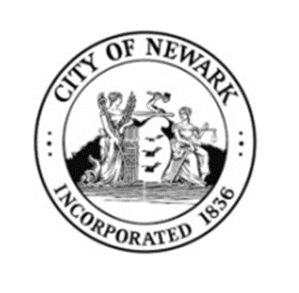

Promoting Scholarship, Leadership & Excellence in S.T.E.M.
CONTESTANT APPLICATION
Miss (15y-18y) ____ Little Miss (11y-14y) ____ Princess (8y-10y) ____
Name: ______________________________________________Age: ___________________________
Parents: ____________________________________ Phone #: ________________________________
Address: ___________________________________________________________________________
School: __________________________________________Grade:_____________________________
Social Media Pages: __________________________________________________________________
School Organizations/Clubs_____________________________________________________________
________________________________________________________________________________________________________________________________________________________________________
Talents/Hobbies:______________________________________________________________________
____________________________________________________________________________________
3 Words that best describe you: __________________________________________________________
Ambition: ___________________________________________________________________________
____________________________________________________________________________________
Jacket Size: S_____________ M____________ L_____________ XL______________
Sponsored by:________________________________________________________________________
Signature: ____________________________________________________________________________________
If under 18 Parent/Guardian:
Signature: ____________________________________________________________________________________
*By signing, I acknowledge I have read and agree to the rules, regulations, terms and guidelines of the pageant. If my child does not have google classroom, I give permission for an account to be created. I understand photos will be taken and utilized for advertising and promotion. WOW-NJ is not responsible for any injuries or lost or stolen items.

Photo Release / Consent
I hereby authorize and consent to the taking of photographs & videos of me or my child by Women of Wellness of New Jersey, it’s agents/vendors or employees. I hereby authorize & consent to the use of such photographs & videos in connection with newspaper stories, television programs, teaching, research, web sites and publicity about Women of Wellness of New Jersey.

I hereby release Women of Wellness of New Jersey, it’s agents/vendors & employees from all liability related to the marketing and use of such photographs & videos.

Parent/Guardian Signature _____________________________________________________________________

Parent/Guardian Print Name____________________________________________________________________

Name of Child ______________________________________________________________________________

Relationship to Child _________________________________________________________________________

Name of Parent/Guardian ______________________________________________________________________

Address ____________________________________________________________________________________

Phone number _______________________________________________________________________________

*Please return completed application to the address below or email:

